WAYNE STATE UNIVERSITY
DEPARTMENT OF RADIATION ONCOLOGY
RADIATION THERAPY TECHNOLOGY PROGRAM

RT-4220: Radionuclide Physics
Fall Semester 2025

Class Times: | 10:00 AM – 11:30 AM; Tuesday and Thursday
Location: | Small Conference Room; Radiation Oncology Center
Instructor: | Kedree Proffitt; Master’s Student
Contact Email: | hv2316@wayne.edu
Contact Phone: | (810) 221-9749
Office Hours: | By Appointment

COURSE OVERVIEW
Students will learn the basic principles of radioactivity, radionuclide production, radiation measurement techniques, clinical use of radionuclides, and various aspects of radiation safety.

LEARNING OBJECTIVES
After this course, students should be able to:
- Describe the basic principles of radioactivity
- Describe the various techniques of radiation measurement
- Describe the clinical application of radionuclides

METHODS OF INSTRUCTION
Mostly teacher-centered instruction; however, there will be some amount of assigned reading, homework, and in-class interactive instruction.
GRADING
The course grade will be determined according to the following table:
Category | Percent of Grade
Homework (Participation) | 10%
Attendance (Participation) | 10%
Exam 1 | 25%
Exam 2 | 25%
Exam 3 | 30%

The instructor will utilize the grading guidelines below to determine the final course grade:
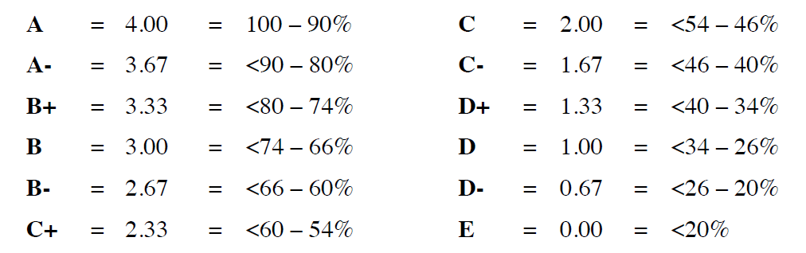
The instructor reserves the right to scale the grades at the end of the term. A lower course grade will not be assigned based on such scaling. A C or lower grade will constitute a failure (F). A grade of “I” (Incomplete) will be given only in the most extraordinary circumstances

EXAMINATION POLICY
All exams are to be taken according to the established schedule. No make-up exams will be given. In case of illness or a legitimate emergency, the grades from Exam 1, 2, or 3 can be replaced by the grade received on an optional exam. The optional exam requirement will not be limited to the type and format of the original examination, and it can be in the form of an oral exam, project, paper, or other assignments. Thorough documentation must be submitted to the instructor prior to granting the student an opportunity to complete an alternative requirement.

ACADEMIC DISHONESTY
Students must not copy material from exams written by other students. You may not consult any references or written material during exams unless you are explicitly allowed to do so (in writing). Following exam grading, students may see their exam papers but will not be allowed to retain them and they must be returned to the instructor. You are asked not to divulge exam questions to future students. This is for their benefit and yours. You share in the responsibility we have as a graduate program to assure that trainees have the ability to appropriately treat patients in a setting which presents grave potential consequences. This of course also implies that you should not attempt to solicit such material from former students. Any acts of academic dishonesty shall be dealt with according to departmental and university policies.

APPEALS POLICY
Details of appeals procedures can be obtained from Jeannetta Greer, Director of the Radiation Therapy Technology Program.

DISABILITY
If you have a documented disability that requires accommodation, you will need to register with Student Disability Services to coordinate your academic accommodations. Once you have your accommodations in place, the instructor will be glad to meet with you privately during office hours to discuss your special needs. Student Disability Services’ mission is to assist the university in creating an accessible community where students with disabilities have an equal opportunity to participate fully in their educational experience at Wayne State University.

RELIGIOUS HOLIDAYS
(from the online Academic Calendar): Because of the extraordinary variety of religious affiliations of the University student body and staff, the Academic Calendar makes no provisions for religious holidays. However, it is the University’s policy to respect the faith and religious obligations of the individual. Students with classes or examinations that conflict with their religious observances are expected to notify their instructors well in advance so that mutually agreeable alternatives may be worked out.
STUDENT SERVICES
The Academic Success Center (1600 Undergraduate Library) assists students with content in select courses and in strengthening study skills. Visit www.success.wayne.edu for schedules and information on study skills workshops, tutoring and supplemental instruction (primarily in 1000 and 2000 level courses). The Writing Center is located on the 2nd floor of the Undergraduate Library and provides individual tutoring consultations free of charge. Visit http://www.clas.wayne.edu/writing/ to obtain information on tutors, appointments, and the type of help they can provide.

SCHEDULE
Date | Lecture # | Topics
09/02 | 1 | Introductions and Review of Rad. Physics
09/04 | 2 | Atomic and Nuclear Physics
09/09 | 3 | Modes of Radioactive Decay; 1
09/11 | 4 | Modes of Radioactive Decay; 2
09/16 | 5 | Statistics of Radioactive Decay; 1
09/18 | 6 | Statistics of Radioactive Decay; 2
09/23 | 7 | Production of Radioactive Materials; 1
09/25 | 8 | Production of Radioactive Materials; 2
09/30 | - | Review for Exam 1
10/02 | - | Exam 1
10/07 | 9 | Radiation Interactions with Matter
10/09 | 10 | Radiation Protection
10/14 | 11 | Detection of Radiation; 1
10/16 | 12 | Detection of Radiation; 2
10/21 | - | WSU Holiday; Fall Break
10/23 | - | Extended Holiday
10/28 | 13 | Nuclear Imaging; 1
10/30 | 14 | Nuclear Imaging; 2
11/04 | - | Review for Exam 2
11/06 | - | Exam 2
11/11 | 15 | Radiopharmaceutical Therapy
11/13 | 16 | Introduction to Brachytherapy
11/18 | 17 | Brachytherapy Calculations
11/20 | 18 | Brachytherapy Applications
11/25 | - | Extended WSU Holiday
11/27 | - | WSU Holiday
12/02 | 19 | Exam 3/ARRT Study Session; 1
12/04 | 20 | Exam 3/ARRT Study Session; 2
12/09 | - | WSU Study Day
12/11 | - | Exam 3

Note that the schedule is subject to change in the event of necessary changes in the instructor's schedule or University closure due to inclement weather or other emergencies.

